PRACITICAL EXAM – DBI202

Họ tên: Nguyễn Đăng Lộc – SE160199 Lớp: SE1616

**Bài B**

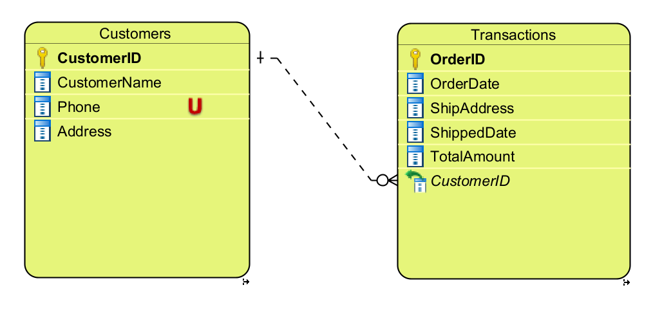**ERD**

**DDL**

CREATE DATABASE DB_ALOSHOP

USE DB_ALOSHOP

CREATE TABLE Customers (

CustomerID char(5) NOT NULL,

CustomerName nvarchar(40) NOT NULL,

Phone char(11) UNIQUE NOT NULL,

Address nvarchar(100) NOT NULL,

PRIMARY KEY (CustomerID)

);

CREATE TABLE Transactions (

OrderID int IDENTITY NOT NULL,

OrderDate datetime NOT NULL,

ShipAddress nvarchar(100) NOT NULL,

ShippedDate datetime NOT NULL,

TotalAmount float(10) NOT NULL,

CustomerID char(5) NOT NULL,

PRIMARY KEY (OrderID)

);

ALTER TABLE Transactions ADD CONSTRAINT FKTransactio403795

FOREIGN KEY (CustomerID) REFERENCES Customers (CustomerID)

ON UPDATE Cascade ON DELETE Cascade;

ALTER TABLE Transactions DROP CONSTRAINT FKTransactio403795;

DROP TABLE Customers;

DROP TABLE Transactions;

**DML**

SELECT CustomerID, CustomerName, Phone, [Address] FROM Customers

SELECT CustomerID, OrderID, OrderDate, ShipAddress, ShippedDate, TotalAmount FROM Transactions

ORDER BY CustomerID

INSERT INTO Customers VALUES('C0001', N'Nguyễn Văn An', '09876543210', N'Quận 9, TP.HCM')

INSERT INTO Customers VALUES('C0002', N'Lê Văn Bình', '09876543211', N'Quận 2, TP.HCM')

INSERT INTO Customers VALUES('C0003', N'Phạm Văn Cường', '09876543210', N'Quận 1, TP.HCM')

INSERT INTO Customers VALUES('C0004', N'Vũ Văn Đức', '09876543211', N'Quận 9, TP.HCM')

INSERT INTO Transactions VALUES('2021-12-10', N'Quận 9, TP.HCM', '2021-12-13', 200000, 'C0001')

INSERT INTO Transactions VALUES('2021-11-29', N'Quận 2, TP.HCM', '2021-12-05', 1011111, 'C0002')

INSERT INTO Transactions VALUES('2021-09-25', N'Quận 2, TP.HCM', '2021-09-26', 98500, 'C0006') -- lỗi

INSERT INTO Transactions VALUES('2021-11-09', N'Quận 9, TP.HCM', '2021-11-10', 555000, 'C0004')

INSERT INTO Transactions VALUES('2021-12-15', N'Quận 9, TP.HCM', '2021-12-17', 90000.5, 'C0001')

UPDATE Customers SET [Address] = N'Quận Tân Bình, TP.HCM' WHERE CustomerID = 'C0003'

DELETE FROM Customers WHERE CustomerID = 'C0004'